# Smart Student Enrollment and learning Portal (Phase 9)

**Goal:**

The goal of this project is to build a Salesforce-based Student Enrollment and Learning Portal that automates the complete admission process. It will streamline student inquiries, course enrollments, and fee tracking while reducing manual effort and delays. Automated notifications and reminders will improve communication with students and faculty. Overall, the system will enhance efficiency, accuracy, and reporting, ensuring a smoother enrollment experience for educational institutes.

**Problem Statement:**

Educational institutes face challenges in managing student inquiries, admissions, and course enrollments due to manual processes. This causes delays, missed follow-ups, and inefficiency. A Salesforce-based portal will automate lead capture, admissions, fee tracking, and notifications, ensuring faster enrollment and better reporting.

# Phase 9: Reporting, Dashboards & Security Review

Phase 9 focuses on **Reporting, Dashboards, and Security Review** within Salesforce. In this phase, various reports and dashboards were created to provide actionable insights, and security measures were applied to ensure that sensitive student and financial data remains protected.

## ****Reports****

* Created an **Admissions Report** to track the number of student inquiries, applications, and confirmed admissions.
* Designed **Fee Collection Reports** to monitor paid, pending, and overdue fees.
* Built **Course Popularity Reports** to analyze which courses and batches had the highest enrollment.
* Enabled filtering and grouping options for faculty and management to analyze data effectively.

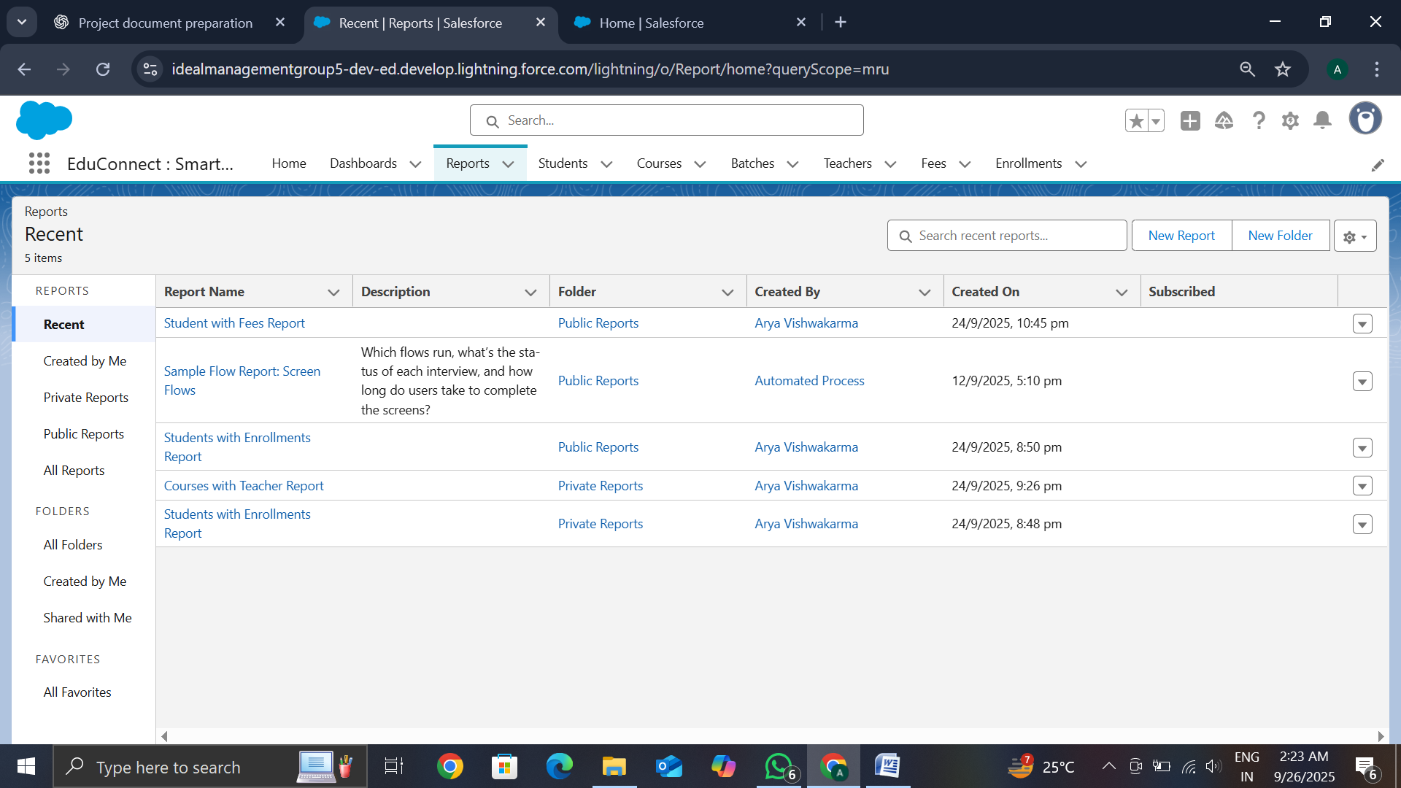

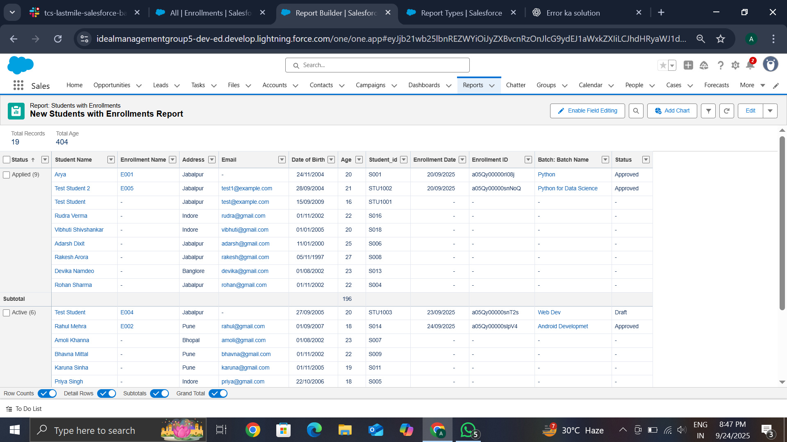

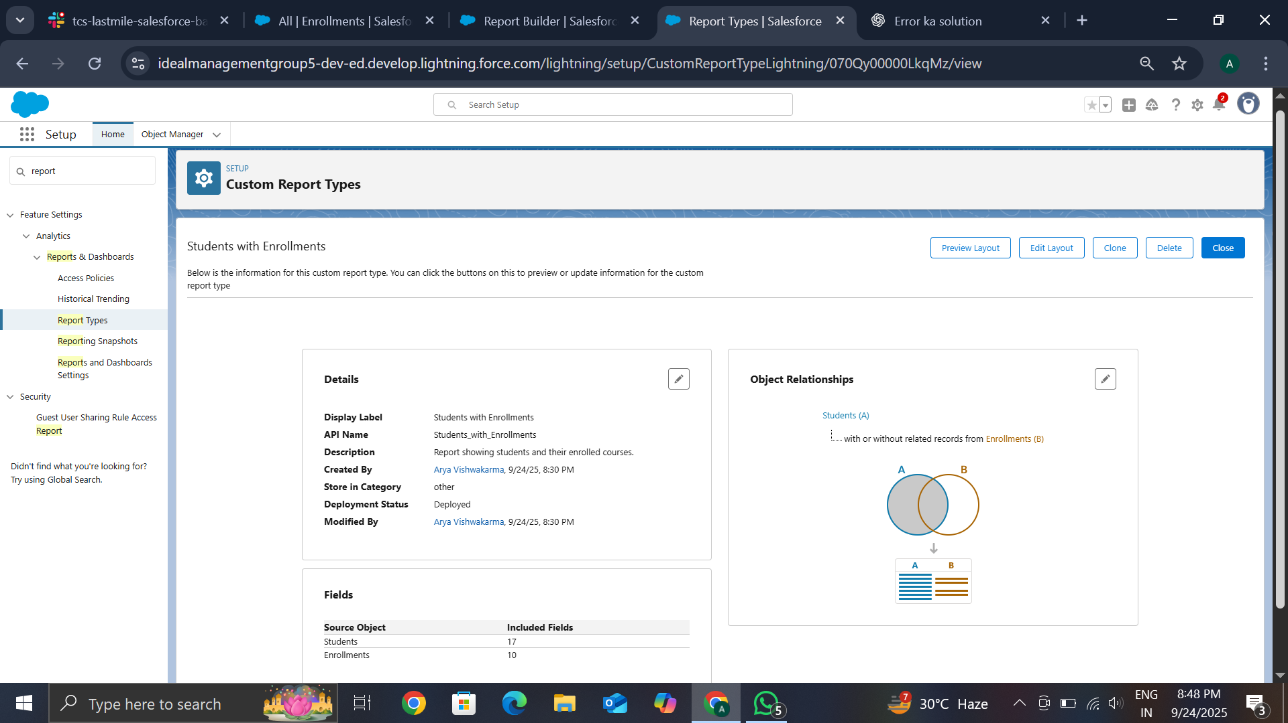

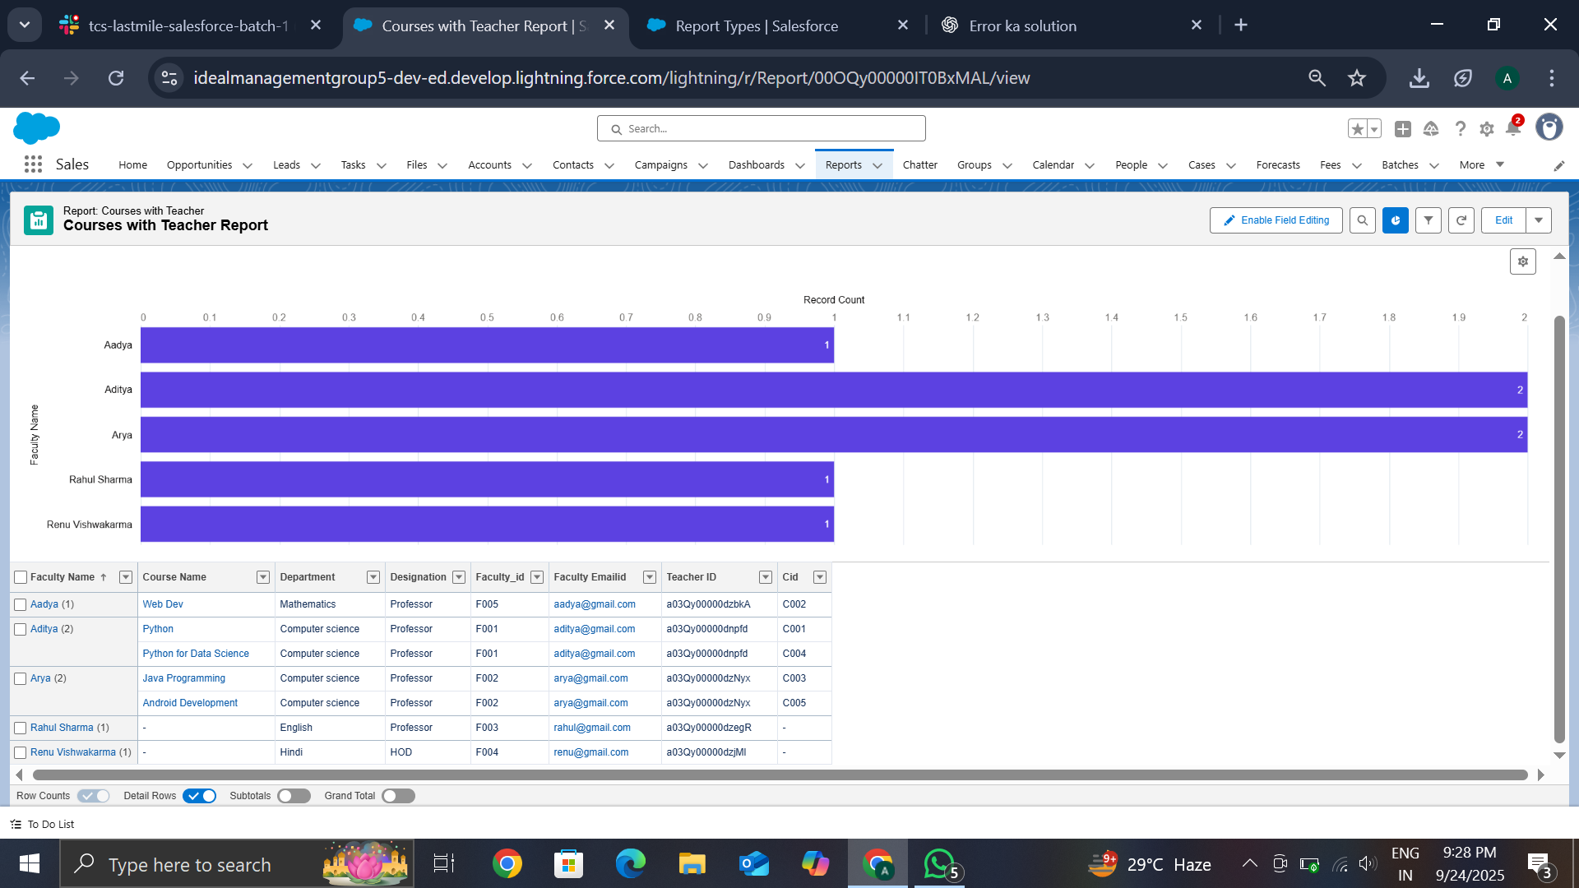

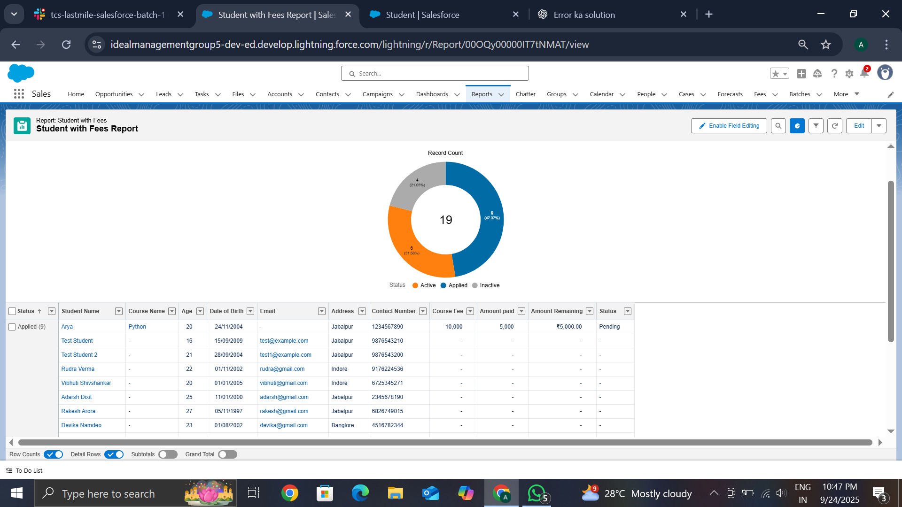

## ****Dashboards****

* Developed a **Management Dashboard** with visual charts showing admissions, revenue, and enrollment trends.
* Configured **Dynamic Dashboards** to ensure that users only see data according to their roles (e.g., faculty, management).
* Used graphs and visual indicators for **real-time decision-making**.

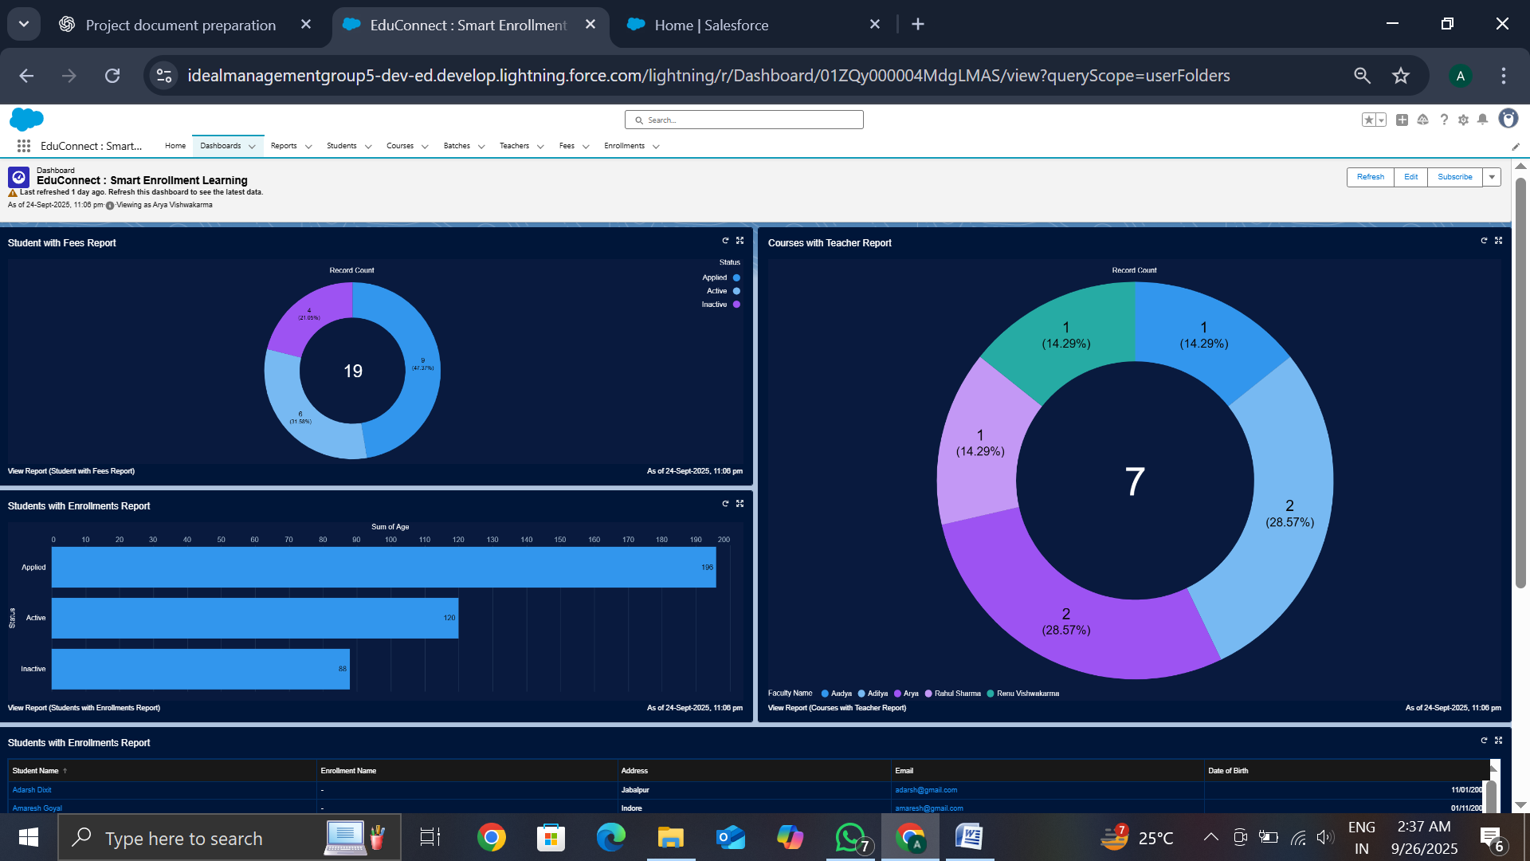

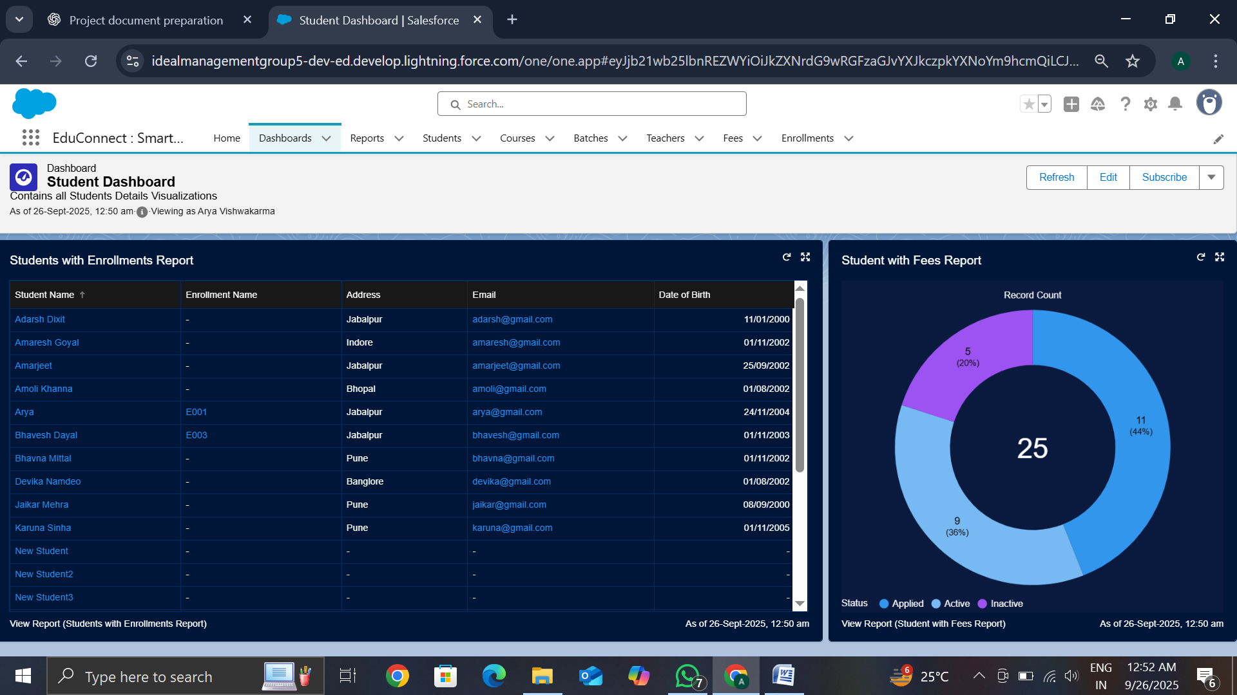

## ****Security Review****

* Applied **Field-Level Security (FLS)** to protect sensitive data such as student personal details and fee records.
* Enabled **Audit Trail** to track configuration and data changes made by administrators.
* Configured **Login IP Ranges** and **Session Settings** to enhance login security.
* Reviewed **Sharing Settings** to ensure controlled access to records based on role hierarchy.

## ****Conclusion****

Phase 9 successfully provided **data-driven insights** through reports and dashboards, while also reinforcing **security and compliance**. With these measures, the system became more **transparent, secure, and reliable**, empowering institutes to make informed decisions while safeguarding student information.